## VM instances Update

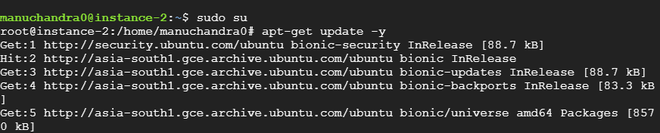

Docker Install

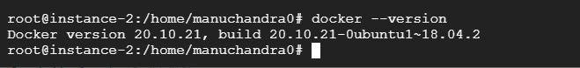

Check docker images



Creator a docker container

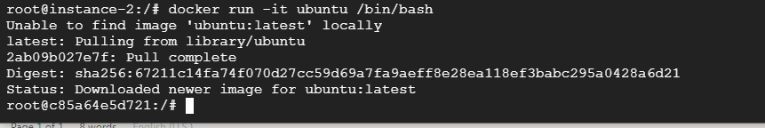

Check docker images

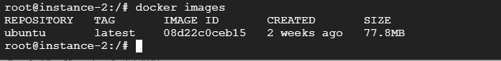

Check docker container



Docker search ubuntu

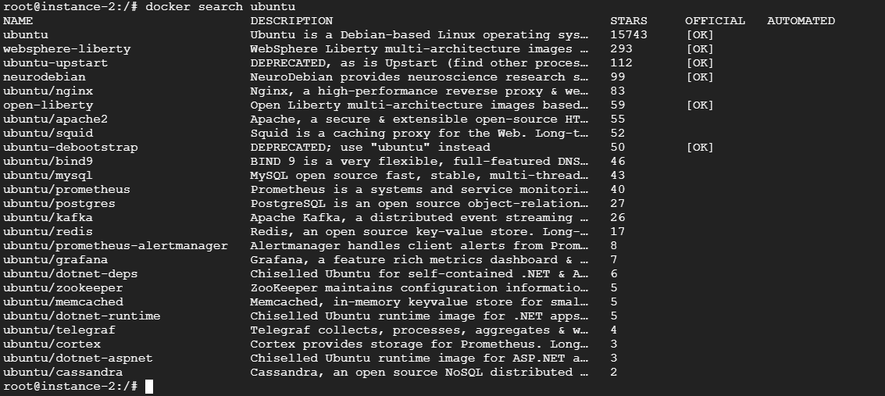

Docker Pull

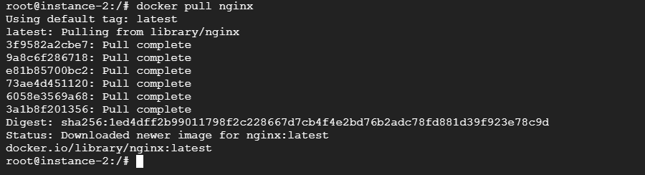

Check docker images



Container name change

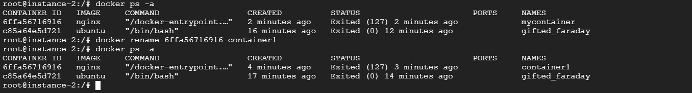

Docker container start

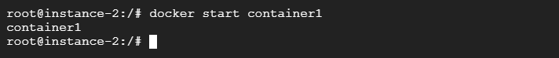

In send the same container

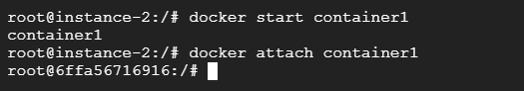

Docker diff check

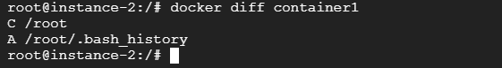

Creator a docker container image

